**SEQUENCE DIAGRAM**

**EXCESS FOOD MANAGEMENT SYSTEM**

LOGARATHAN S V – 2022503047

SAHANA S – 2022503049

26.09.2024

LOGIN :

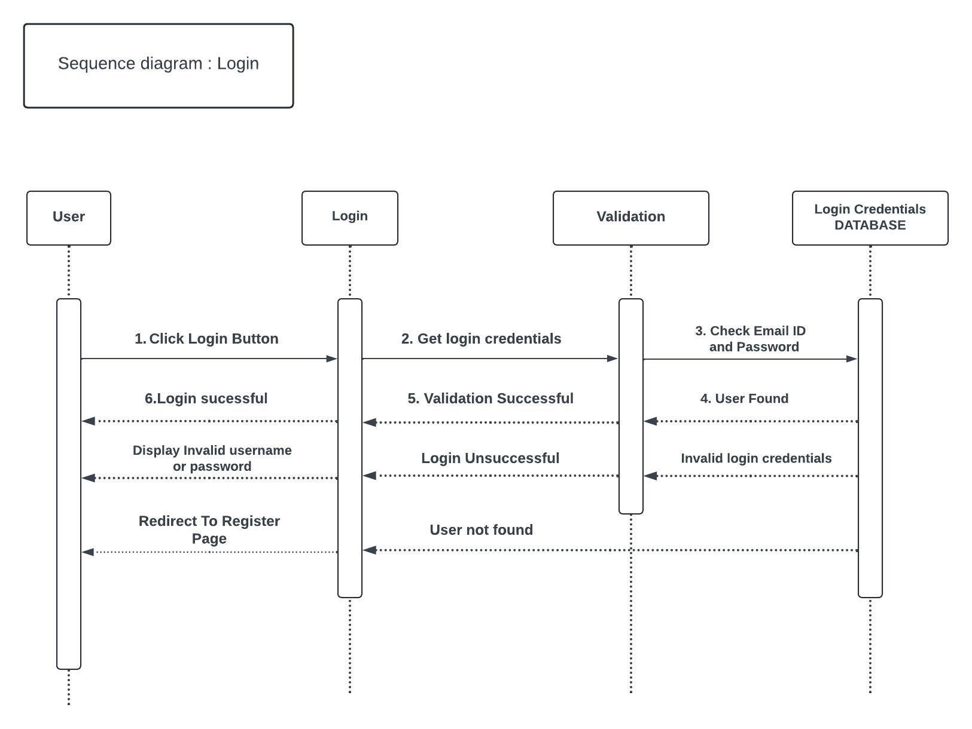

SYSTEM :

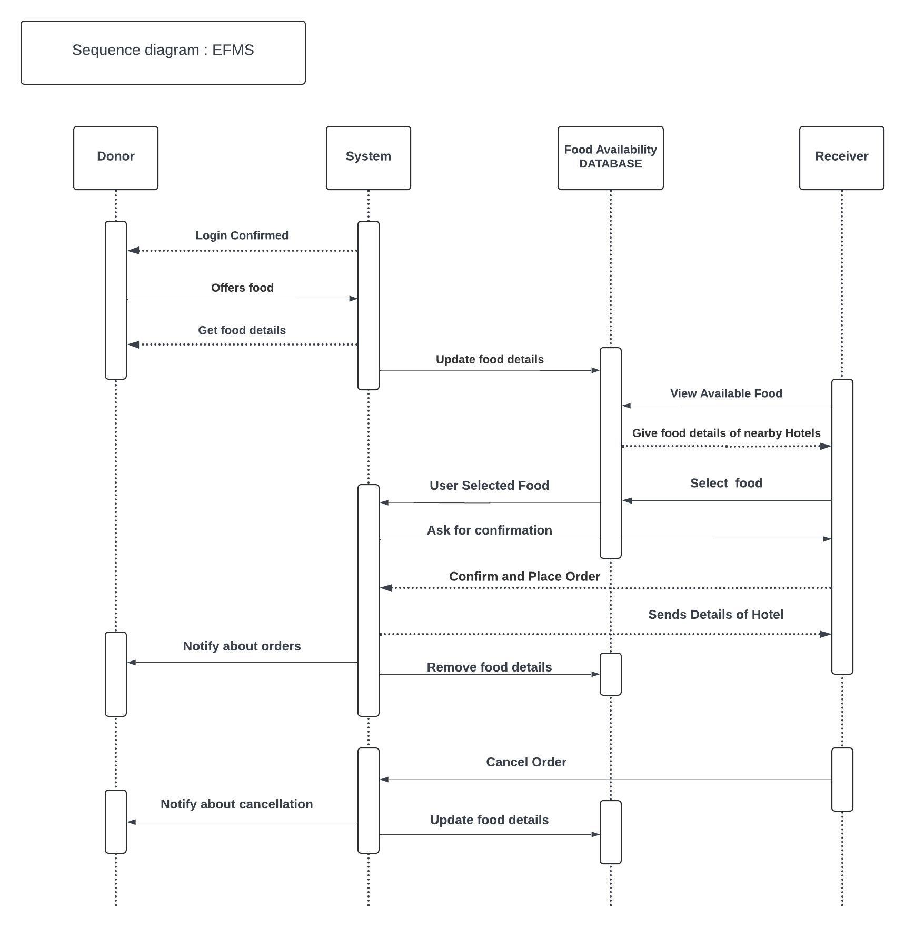

FEEDBACK :

